Word cloud
Figure 1 and Figure 2 present word clouds for two different artist groups based on clean lyrics.
The visualizations indicate that both groups frequently use emotional and relational terms, such as love, feel, and need. However, artists with lower popularity exhibit a broader range of thematic expressions, including words related to daily life and social context (e.g., home and gang).
This suggests that lower-popularity artists tend to explore more diverse lyrical topics, whereas top artists focus more heavily on a narrower set of emotional themes.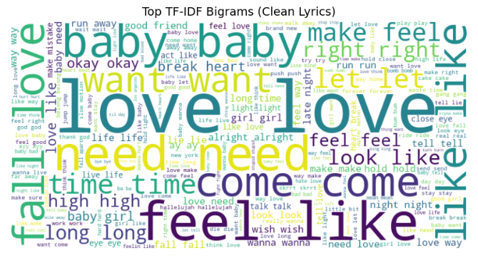
Figure 1 Word cloud of top artist
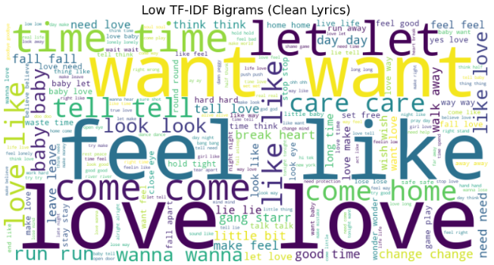
Figure 2 Word cloud of low artist

Sentiment
Figure 3 shows the overlaid sentiment distributions of top- and low-playcount songs based on the compound sentiment score.
Both groups exhibit a strongly skewed distribution toward positive sentiment, indicating that emotionally positive language is prevalent in song lyrics overall. However, top-playcount songs display a higher concentration of extreme positive sentiment values near 1.0 compared to low-playcount songs. In contrast, low-playcount songs show a relatively wider spread across neutral and negative sentiment ranges.
These results suggest that highly popular songs tend to emphasize stronger positive emotional expression, whereas less popular songs exhibit more emotional diversity.
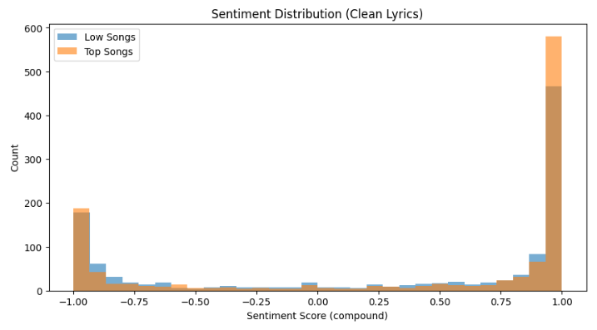
Figure 4 Sentiment distribution of top and low artist

